Lab Photo-interrupt

Introduction
A photo-interrupter is a sensor that arranges light-emitting component and light-receiving
component face-to-face and packages them together. It applies the principle that light is
interrupted when an object passes through the sensor. Therefore, photo-interrupters are
widely used in speed measurement.

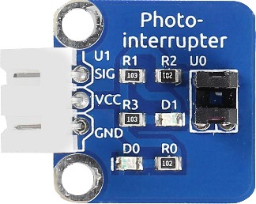 | Components  - 1 * Arduino Uno board  - 1 * USB data cable  - 1 * Photo-interrupter module  - Several jumper wires

Experimental Principle
Basically a photo-interrupter consists of two parts: transmitter and receiver. The transmitter
(e.g., an LED or a laser) emits light and then the light goes to the receiver. If that light beam
between the transmitter and receiver is interrupted by an obstacle, the receiver will detect
no incoming light even for a moment and the output level will change. In this experiment,
we will turn an LED on or off by using this change.

Experimental Procedures
Step 1: Build the circuit
Photo-interrupter Module Arduino Uno
S --------------------------------------- Pin7
GND -------------------------------------- GND
Vcc --------------------------------------- 5V
Step 2: Program
Step 3: Compile
Step 4: Upload the sketch to Arduino Uno

Task: stick a piece of paper in the gap of the sensor, and the LED attached to pin 13 on the
Arduino Uno will go out; remove the paper, and then the LED attached to pin 13 will light up again.

A) Design and implement
Hardware implementation with the Arduino board and the bread board
B) Program
const int photoPin = 7; //the number of the key pin
const int ledPin = 13;//the number of the led pin /***************************************************/
void setup()
{
pinMode(photoPin,INPUT);
pinMode(ledPin,OUTPUT);//initialize the led pin as output
pinMode(ledPin,OUTPUT); //initialize led as an output
}
/***************************************************/
void loop()
{
boolean Value=digitalRead(photoPin);

//if it is blocked, the state is HIGH, turn off LED
if(Value ==HIGH )
{
digitalWrite(ledPin,LOW);//turn off the led
}
else
{
digitalWrite(ledPin,HIGH);//turn on the led
}
}
/******************************************************/

C) Test
- Test theHardware implementation with the arduino board
- Change the program or connection for the LEDs as below
Original program your program to be modified
Stick a piece of paper LEDs: Off LEDs: On
Remove the paper LEDs : On LEDs : Off
Signal pin 7 pin 8

Deliverables
Lab report
    - Introduction
    - Body: How to connect, explanation of the sensor internal circuit, debugging, and others
    - Conclusion : lessons from the experiment
    - Attachments: revised code, picture

